Programming Exercise 13
Pedro Clavero De Dios
April 26, 2026
COP 2373
Screenshots:
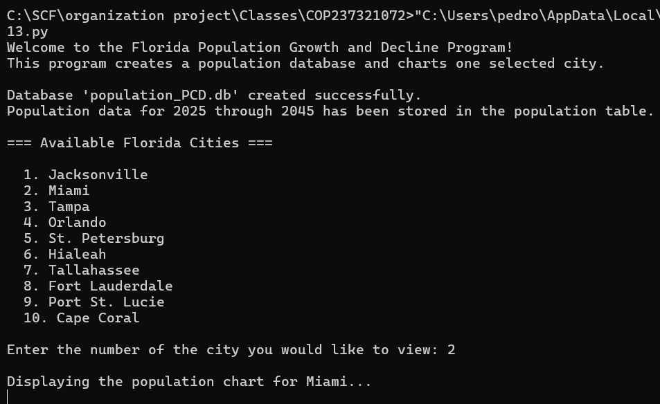
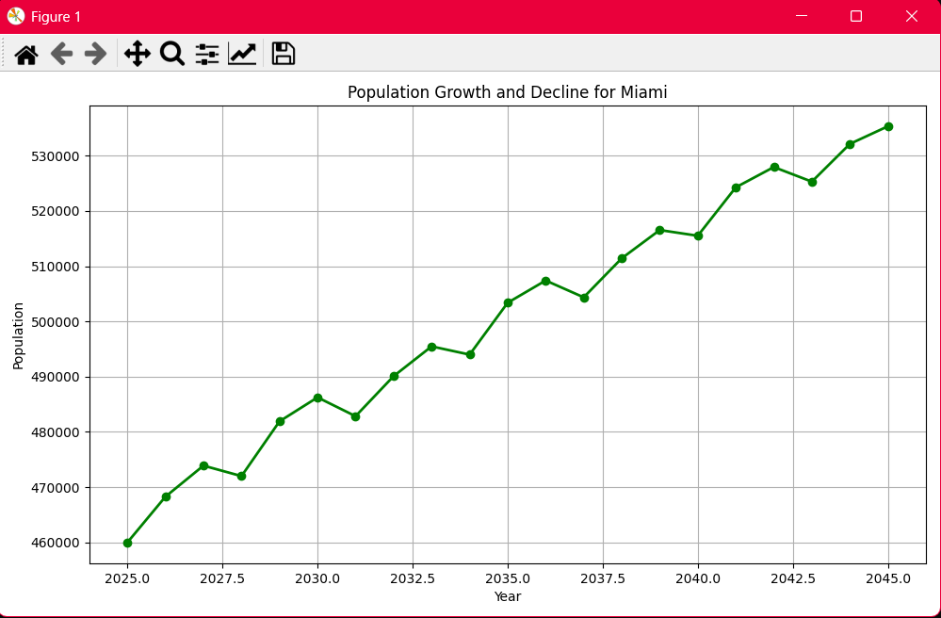

GitHub Repo Link: https://github.com/Pclav34/PC_COP2373

